CAREER PATH AI
Machine Learning with Python Internship Report-2026
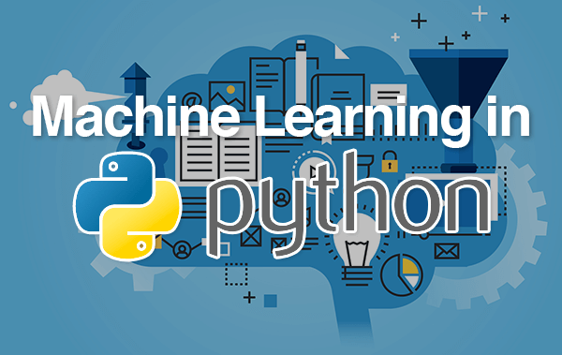

Team members:
1.Dokku Bala Thripura Sundari (23BQ1A6129) -VVIT
2.Alisetty Venkata Bhumica (23BQ1A6102) -VVIT
3.Battula pravallika(23BQ1A6108) -VVIT
4.Boddu Abhinaya sri(23BQ1A6114) -VVIT
5.Alla Venkata Naga Durga Ganesh Sai(23BQ1A6103) -VVIT
TABLE OF CONTENTS
S.No | Content | Page No.
1 | Introduction to RecuitX AI | 4
2 | Problem Statement | 5
3 | Objectives of the Project | 6
4 | Internship Overview | 7
5 | Technology Stack | 8-9
6 | Python Libraries Used | 10-11
7 | System Architecture | 12-13
8 | Dataset Collection and Processing | 14-15
9 | Resume Parsing Module | 16-17
10 | Natural Language Processing (NLP) | 18-19
11 | Skill Extraction System | 20
12 | Resume Scoring Algorithm | 21
13 | ATS Compatibility Analysis | 22
14 | Job Role Prediction using Machine Learning | 23
15 | Company Recommendation Engine | 24
16 | Skill Gap Analysis | 25
17 | Learning Roadmap Generator | 26
18 | Interview Question Generator | 27
19 | Salary Prediction Module | 28
20 | AI Career Assistant Chatbot | 29
21 | User Interface Design | 30
22 | Testing and Validation | 31-35
23 | Future Enhancements | 36
24 | Conclusion | 37
25 | References | 38

Introduction to RecuitX AI

RecuitX AI is an intelligent recruitment assistance platform developed using Python, Machine Learning, and Natural Language Processing technologies. The primary objective of this system is to simplify and automate the recruitment process by providing smart resume analysis, job role prediction, skill assessment, and career guidance. Traditional recruitment methods often require significant manual effort from recruiters to evaluate resumes and identify suitable candidates. RecuitX AI addresses this challenge by leveraging Artificial Intelligence to perform automated candidate evaluation with greater speed and accuracy.
The platform is designed to assist students, fresh graduates, and job seekers in improving their employability by analyzing their resumes and providing personalized recommendations. The system extracts information from resumes, identifies technical and non-technical skills, predicts suitable job roles, checks ATS compatibility, and recommends learning resources for career growth. By utilizing Machine Learning algorithms, the platform can compare candidate profiles with industry requirements and generate meaningful insights.
RecuitX AI integrates multiple modules into a unified system. These modules include resume parsing, skill extraction, job prediction, company recommendation, salary prediction, interview question generation, and AI chatbot support. Each module contributes to enhancing the overall recruitment experience for both candidates and recruiters. The platform can process resumes in PDF format and convert unstructured data into structured information that can be analyzed efficiently.
One of the major advantages of RecuitX AI is its ability to identify skill gaps. Candidates often struggle to understand what skills are required for their desired job roles. The system compares the candidate’s skills with industry expectations and provides suggestions for improvement. This helps users create a targeted learning plan and prepare effectively for future opportunities.
The project demonstrates the practical application of Artificial Intelligence and Machine Learning in human resource management. It showcases how modern technologies can improve recruitment efficiency, reduce manual workload, and provide data-driven career guidance. Through this internship project, valuable experience was gained in Python programming, machine learning implementation, data processing, NLP techniques, and software development practices.

2. Problem Statement

Recruitment is one of the most important processes in any organization. Companies receive thousands of resumes for various job openings, making it difficult for recruiters to manually review and evaluate each application. This manual process is time-consuming, error-prone, and often leads to inconsistencies in candidate selection. Additionally, many candidates are unaware of the specific skills and qualifications required for their desired job roles, resulting in poorly optimized resumes and reduced chances of selection.
Another significant challenge is the increasing use of Applicant Tracking Systems (ATS) by organizations. ATS software automatically filters resumes based on predefined criteria before they reach recruiters. Many qualified candidates are rejected because their resumes are not properly formatted or do not contain the necessary keywords. As a result, candidates often miss opportunities despite possessing relevant skills and qualifications.
The lack of personalized career guidance further complicates the recruitment process. Candidates frequently struggle to identify suitable job roles, understand industry expectations, and determine the skills they need to acquire. Without proper guidance, they may invest time in learning irrelevant technologies or applying for unsuitable positions.
Recruiters also face challenges in matching candidates with appropriate job roles. Manual evaluation of skills, experience, and educational qualifications can be inefficient and subjective. Organizations require intelligent systems that can analyze candidate profiles quickly and accurately while minimizing bias and human error.
To address these issues, the RecuitX AI project was developed. The system utilizes Artificial Intelligence, Machine Learning, and Natural Language Processing to automate resume analysis and provide personalized recommendations. It helps candidates improve their resumes, identify skill gaps, predict suitable job roles, and prepare for interviews. At the same time, it assists recruiters by streamlining candidate evaluation and improving recruitment efficiency.
The project aims to bridge the gap between candidate capabilities and industry requirements. By automating critical recruitment tasks and providing data-driven insights, RecuitX AI contributes to a more efficient, transparent, and intelligent recruitment ecosystem.

3. Objectives of the Project

The primary objective of the RecuitX AI project is to develop an intelligent recruitment assistance platform capable of analyzing resumes and providing valuable career recommendations using Artificial Intelligence and Machine Learning techniques. The system aims to simplify recruitment processes while helping candidates improve their employability and career readiness.
One of the key objectives is to automate resume analysis. The system should be capable of extracting information such as personal details, educational qualifications, technical skills, certifications, projects, and work experience from uploaded resumes. This information serves as the foundation for further analysis and recommendations.
Another important objective is to implement a resume scoring mechanism. The scoring algorithm evaluates resumes based on various parameters, including skills, experience, education, certifications, and ATS compatibility. The generated score helps candidates understand the overall quality of their resumes and identify areas requiring improvement.
The project also aims to predict suitable job roles using Machine Learning algorithms. By analyzing candidate profiles and comparing them with industry datasets, the system recommends job positions that align with the candidate’s qualifications and skill set. This feature enables users to focus on relevant career opportunities.
Skill gap analysis is another major objective of the project. The system identifies missing skills required for desired job roles and recommends learning resources to bridge these gaps. This helps candidates enhance their competencies and remain competitive in the job market.
Additional objectives include company recommendation, interview question generation, salary prediction, ATS compatibility checking, and AI chatbot support. These features collectively create a comprehensive career guidance platform that supports users throughout their job search journey.
The project also aims to provide practical exposure to Artificial Intelligence, Machine Learning, Python programming, Natural Language Processing, and database management. Through the development of this system, advanced technical concepts are applied to solve real-world recruitment challenges effectively and efficiently.

4. Internship Overview

The RecuitX AI project was developed as part of a two-month internship conducted under Naipunyam. The internship provided an opportunity to gain practical knowledge and hands-on experience in the fields of Artificial Intelligence, Machine Learning, Natural Language Processing, and Python application development. The training was conducted under the guidance of Ruthu Madam, who provided valuable support and technical direction throughout the internship period.
The internship focused on understanding how Artificial Intelligence can be applied to solve real-world problems in recruitment and career guidance. During the training, various technologies and tools were introduced, including Python programming, machine learning libraries, NLP techniques, database systems, and web application development frameworks. These technologies formed the foundation for the development of the RecuitX AI project.
Several stages were involved in the project development process. Initially, requirements were gathered and analyzed to identify the challenges faced by recruiters and job seekers. Following this, system architecture was designed, and suitable technologies were selected. Data preprocessing techniques were applied to prepare datasets for machine learning models. Various modules such as resume parsing, skill extraction, ATS analysis, job prediction, and chatbot integration were then implemented and tested.
The internship emphasized both technical learning and project management skills. Regular reviews, coding exercises, debugging sessions, and performance evaluations helped improve problem-solving abilities and software development practices. Exposure to real-world project workflows enhanced understanding of teamwork, communication, documentation, and software lifecycle management.
Through this internship, valuable experience was gained in developing AI-based applications capable of delivering practical solutions. The project successfully demonstrates the integration of multiple technologies into a unified recruitment platform. The knowledge acquired during this internship has strengthened technical skills and provided a strong foundation for future work in Artificial Intelligence, Machine Learning, and software development domains.

5. Technology Stack

The RecuitX AI project was developed using a modern technology stack that combines programming languages, machine learning libraries, database systems, and user interface technologies. The primary programming language used in the project is Python due to its simplicity, flexibility, and extensive support for Artificial Intelligence and Machine Learning applications. Python provides a rich ecosystem of libraries that enable efficient data processing, machine learning model development, and web application creation.
For machine learning implementation, libraries such as Scikit-learn were utilized. These libraries provide algorithms for classification, prediction, and data analysis. The job role prediction module relies on machine learning techniques to identify suitable job positions based on candidate skills and qualifications. Natural Language Processing tasks such as skill extraction and resume analysis were implemented using NLTK and SpaCy, which provide tools for text tokenization, keyword extraction, and language processing.
The user interface was developed using Streamlit, a Python framework that enables rapid development of interactive web applications. Streamlit simplifies deployment and allows users to upload resumes, view analysis reports, and interact with AI-powered features through a user-friendly interface.
The Technology Stack of RecuitX AI refers to the set of tools, frameworks, and programming languages used to build the system. It forms the foundation of the entire application and ensures smooth development and execution of all modules.
The frontend of the system is designed using web technologies such as HTML, CSS, and JavaScript to create a user-friendly interface. The backend is developed using Python, which handles data processing, machine learning models, and API integration.
Flask or Django framework is used to connect frontend and backend components efficiently. These frameworks help in creating web-based applications and managing server-side logic.
Machine learning models are implemented using libraries like Scikit-learn and TensorFlow. These libraries support classification, prediction, and recommendation tasks within the system.
The database is managed using MySQL or MongoDB, which stores user data, resume information, job descriptions, and analysis results. This ensures data persistence and easy retrieval.
Overall, the technology stack provides a scalable and efficient environment for developing the RecuitX AI system.

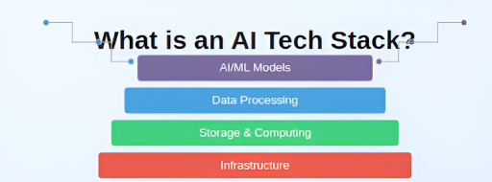

6. Python Libraries Used

Python libraries play a critical role in the successful implementation of the RecuitX AI project. Various libraries were selected to handle different functionalities including machine learning, natural language processing, data analysis, visualization, and web application development.
Pandas was used extensively for data manipulation and preprocessing. It provides data structures such as DataFrames that simplify handling large datasets. NumPy was utilized for numerical computations and mathematical operations required during machine learning model training and evaluation.
Scikit-learn served as the primary machine learning library. It provides algorithms for classification, regression, clustering, and model evaluation. In the job role prediction module, Scikit-learn algorithms were used to train predictive models capable of recommending suitable job positions based on resume content.
Natural Language Processing was implemented using NLTK and SpaCy. These libraries provide functionalities such as tokenization, stemming, lemmatization, stop-word removal, and named entity recognition. They were essential for extracting meaningful information from resumes and identifying candidate skills.
Streamlit was selected for developing the web interface. It allows rapid creation of interactive dashboards and simplifies user interactions. Through Streamlit, users can upload resumes, view analysis results, and receive recommendations.
PyPDF2 and pdfplumber were employed for PDF text extraction. These libraries enable efficient processing of uploaded resumes and conversion of unstructured PDF content into structured text.
Matplotlib and Seaborn were used to generate charts and visualizations. These visual representations help users understand their resume scores, skill distributions, and career recommendations more effectively.
The combination of these Python libraries significantly accelerated development and enabled the implementation of advanced AI functionalities within the RecuitX AI platform.
Python libraries play an important role in the development of RecuitX AI by providing pre-built functions and tools for data processing, machine learning, and visualization.
Libraries such as NumPy and Pandas are used for numerical computations and data manipulation. They help in handling structured and unstructured resume data efficiently.
Scikit-learn is used for implementing machine learning algorithms such as classification, clustering, and similarity matching. It is essential for resume scoring and job prediction modules.
Natural Language Toolkit (NLTK) and spaCy are used for Natural Language Processing tasks like tokenization, stemming, lemmatization, and named entity recognition.
Matplotlib and Seaborn are used for data visualization, helping in generating graphs and charts for analysis results.
Flask is used to build the web application interface and connect backend logic with the frontend system.

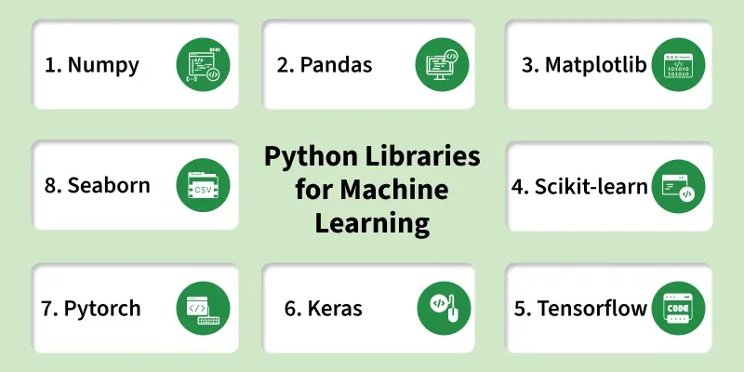

7. System Architecture

The architecture of RecuitX AI is designed to ensure efficient processing of resumes and generation of intelligent recommendations. The system follows a modular architecture where each component performs a specific function while interacting seamlessly with other modules.
The process begins when a user uploads a resume through the Streamlit interface. The uploaded PDF is sent to the resume parsing module, which extracts text and identifies important information such as personal details, education, skills, certifications, and work experience.
The extracted data is forwarded to the Natural Language Processing module. This module cleans and preprocesses the text by removing unnecessary symbols, stop words, and formatting inconsistencies. The processed text is then analyzed to identify skills and keywords relevant to different job domains.
The System Architecture of RecuitX AI describes the overall structure and interaction between different components of the system.
The architecture follows a layered approach consisting of the presentation layer, application layer, and data layer. Each layer has a specific responsibility in the system.
The presentation layer is the user interface where users upload resumes and view results. It is designed to be simple and interactive.
The application layer contains the core logic of the system. It includes NLP processing, machine learning models, resume scoring, and recommendation engines.
The data layer manages storage of resumes, job descriptions, and analysis outputs using databases.
The system architecture ensures smooth communication between all components, making RecuitX AI efficient, scalable, and modular in design.

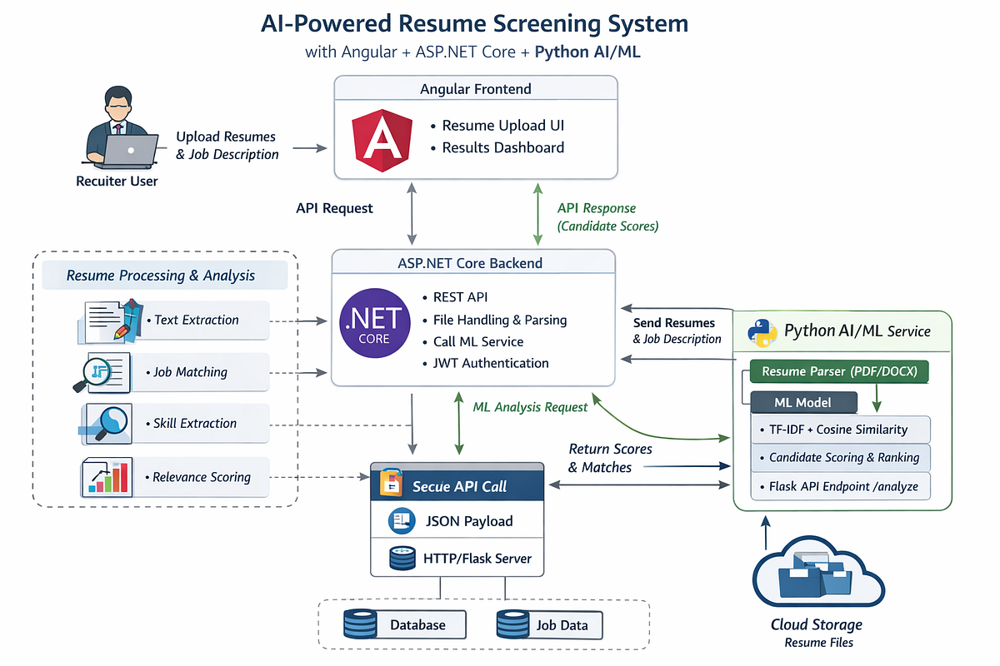

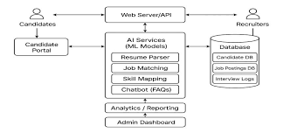

8. Dataset Collection and Processing

Data is the foundation of any machine learning application. For RecuitX AI, relevant datasets were collected from publicly available recruitment, job portal, and career development resources. These datasets contained information about job roles, required skills, educational qualifications, salary ranges, and industry trends.
The collected data underwent preprocessing to ensure accuracy and consistency. Data cleaning involved removing duplicate entries, correcting missing values, eliminating irrelevant records, and standardizing formats. These steps improved data quality and enhanced machine learning model performance.
Text preprocessing techniques were applied to resume and job description datasets. Tokenization, stop-word removal, stemming, and lemmatization were performed using NLP libraries. These processes converted raw textual data into structured representations suitable for analysis.
Feature extraction techniques such as TF-IDF were used to convert textual information into numerical vectors. These vectors enabled machine learning algorithms to identify relationships between candidate profiles and job requirements.
Dataset Collection and Processing is one of the most important phases in the development of the RecruitX AI system. The effectiveness and accuracy of any Artificial Intelligence or Machine Learning model largely depend on the quality, quantity, and relevance of the data used during training and evaluation. Therefore, a well-structured dataset serves as the foundation for building reliable recruitment and career recommendation solutions.
The primary objective of dataset collection is to gather diverse and representative data that reflects real-world recruitment scenarios. RecruitX AI requires information related to candidate profiles, resumes, job descriptions, skills, educational qualifications, work experience, certifications, salary information, and industry requirements. This data helps the system learn patterns and relationships that are essential for generating accurate predictions and recommendations.
Datasets are collected from multiple sources to ensure comprehensive coverage of different industries, job roles, and skill categories. Common data sources include online job portals, publicly available recruitment datasets, sample resumes, professional networking platforms, educational resources, and open-source repositories. Job descriptions from various organizations are also collected to understand employer expectations and hiring requirements across different domains.
The collected data often contains inconsistencies, errors, duplicate records, and incomplete information. Therefore, data preprocessing is performed to improve dataset quality and prepare the information for machine learning applications. Data preprocessing is a critical step because raw data is rarely suitable for direct use in predictive models.
The first stage of preprocessing involves data cleaning. During this process, duplicate records are identified and removed to prevent redundancy. Missing values are handled using appropriate techniques such as replacement, estimation, or removal depending on the significance of the missing information. Inconsistent entries and incorrect values are corrected to maintain data integrity.
Text-based information such as resumes and job descriptions undergo extensive text cleaning procedures. Natural Language Processing (NLP) techniques are applied to remove unnecessary elements including HTML tags, special symbols, punctuation marks, URLs, extra spaces, and irrelevant characters. These cleaning operations help standardize the textual data and improve its suitability for further analysis.

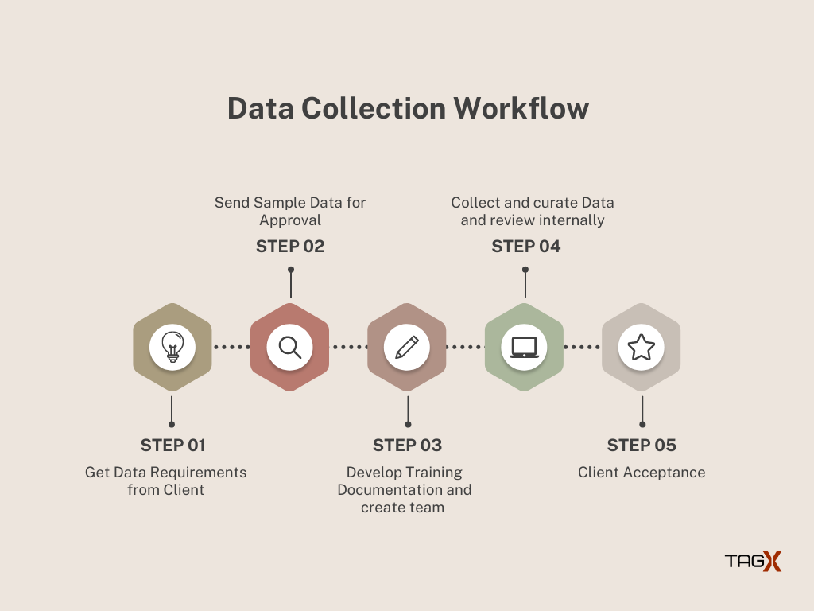

9. Resume Parsing Module

The Resume Parsing Module is one of the most important components of RecuitX AI. Its primary purpose is to automatically extract relevant information from uploaded resumes and convert it into a structured format suitable for analysis.
When a user uploads a PDF resume, the system uses PDF extraction libraries to retrieve text content. The extracted text often contains formatting inconsistencies, special characters, and unnecessary spaces. Therefore, preprocessing techniques are applied to clean and normalize the data.
The parser identifies key sections such as personal information, education, skills, certifications, projects, internships, and work experience. Regular expressions and NLP techniques are used to detect patterns and extract specific details accurately.
The extracted information is organized into structured fields and stored in the database. This structured profile serves as the foundation for subsequent modules including resume scoring, ATS analysis, job prediction, and company recommendation.
Automated resume parsing eliminates manual data entry and significantly reduces processing time. It also ensures consistency in candidate evaluation and improves the efficiency of recruitment workflows.
The Resume Parsing Module is one of the core components of the RecruitX AI system. Its primary function is to automatically extract relevant information from candidate resumes and convert unstructured data into a structured format that can be analyzed by various AI and Machine Learning modules. Since resumes are often submitted in different formats and layouts, this module ensures that important information is captured accurately and consistently for further processing.
The main objective of the Resume Parsing Module is to eliminate manual data entry and automate the resume screening process. Recruiters often receive hundreds or thousands of resumes for a single job opening, making manual review time-consuming and inefficient. By automatically extracting key details from resumes, the system significantly reduces processing time and improves recruitment efficiency.
The module supports multiple document formats, including PDF, DOCX, TXT, and other commonly used resume file types. When a candidate uploads a resume, the system first converts the document into machine-readable text using document parsing techniques. This conversion process ensures that textual information can be analyzed regardless of the original file format.
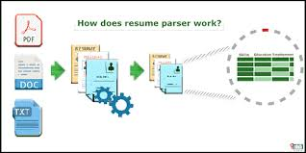

After text extraction, the module applies Natural Language Processing (NLP) techniques to identify and classify important sections within the resume. These sections typically include personal information, educational qualifications, technical skills, certifications, work experience, projects, achievements, and contact details. By understanding the structure and content of the resume, the system can organize information into predefined categories.
Regular Expressions (Regex) play an important role in extracting specific patterns such as phone numbers, email addresses, LinkedIn profiles, dates, and other structured information. Regex-based extraction improves accuracy when identifying commonly formatted details within resumes. For example, email addresses and phone numbers can be detected using predefined pattern-matching rules
The module also uses Named Entity Recognition (NER), a Natural Language Processing technique that helps identify entities such as names, organizations, institutions, locations, job titles, and certifications. NER enables the system to understand contextual information and extract relevant details even when resumes use different formats and writing styles.

10. Natural Language Processing (NLP)

Natural Language Processing is a branch of Artificial Intelligence that enables computers to understand and analyze human language. In RecuitX AI, NLP plays a crucial role in extracting meaningful insights from resumes and job descriptions.
The NLP process begins with text preprocessing. Raw resume text is cleaned by removing special characters, punctuation, and irrelevant symbols. Tokenization divides text into smaller units called tokens. Stop-word removal eliminates common words that do not contribute significant meaning.
Lemmatization and stemming are applied to reduce words to their root forms. This improves consistency and helps machine learning models recognize similar concepts expressed using different word forms.
Named Entity Recognition identifies entities such as skills, technologies, educational institutions, and certifications. Keyword extraction techniques detect important terms that influence resume evaluation and job recommendations.
NLP is also used to compare candidate skills with job requirements. Semantic similarity algorithms analyze relationships between terms and identify relevant matches even when exact keywords are absent.
The implementation of NLP significantly enhances the accuracy of resume analysis and recommendation generation. It enables RecuitX AI to understand candidate profiles more effectively and provide personalized career guidance based on meaningful insights extracted from textual data.
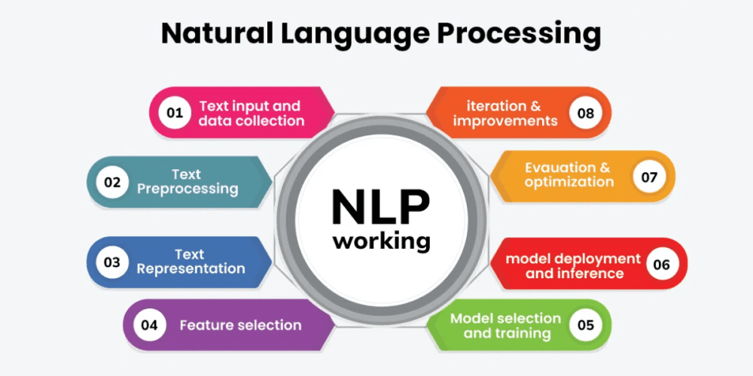

Natural Language Processing is a branch of Artificial Intelligence that enables computers to understand and analyze human language. In RecuitX AI, NLP plays a crucial role in extracting meaningful insights from resumes and job descriptions.
The NLP process begins with text preprocessing. Raw resume text is cleaned by removing special characters, punctuation, and irrelevant symbols. Tokenization divides text into smaller units called tokens. Stop-word removal eliminates common words that do not contribute significant meaning.
Natural Language Processing (NLP) is a core technology used in the RecruitX AI system to analyze, understand, and process human language in resumes, job descriptions, and user interactions. NLP is a branch of Artificial Intelligence that enables computers to interpret, analyze, and generate human-readable text. In RecruitX AI, NLP plays a vital role in transforming unstructured textual information into meaningful insights that support intelligent recruitment and career guidance functionalities.
The primary objective of NLP within the system is to extract valuable information from resumes and job descriptions automatically. Since resumes are typically written in free-text format, it can be challenging for traditional systems to understand their content. NLP techniques help convert this unstructured data into structured information that can be processed by Machine Learning models and recommendation engines.
The NLP process begins with text extraction from uploaded resumes and job descriptions. Once the text is obtained, several preprocessing steps are performed to clean and standardize the data. These steps include removing special characters, punctuation marks, extra spaces, URLs, and irrelevant symbols. The text is then converted into a consistent format to improve analysis accuracy.
Tokenization is one of the first NLP techniques applied during preprocessing. It involves breaking large blocks of text into smaller units called tokens, such as words or phrases. This helps the system analyze individual terms and understand the overall meaning of the content. Tokenization serves as the foundation for many advanced NLP operations performed within the RecruitX AI platform.

17. Skill Extraction System

The Skill Extraction System is one of the most important modules in RecuitX AI, designed to identify and extract meaningful skills from unstructured resume data. Resumes usually contain a mixture of sentences, bullet points, and descriptions, making it difficult for systems to directly understand candidate capabilities. This module solves that problem by converting raw text into structured skill information.
The system uses Natural Language Processing techniques to scan the entire resume content and detect skill-related keywords. These skills may include programming languages such as Python, Java, or C++, frameworks like TensorFlow or React, and domain-specific expertise such as Data Science, Web Development, or Machine Learning.
To improve accuracy, the system maintains a predefined skill database that contains commonly used technical and soft skills. This allows the system to match extracted words with known skill patterns. In addition, synonym mapping is applied so that similar terms such as “ML” and “Machine Learning” are treated as the same skill.
The extracted skills are further categorized into groups such as technical skills, analytical skills, communication skills, and domain-specific skills. This categorization helps in better evaluation of candidates during resume scoring and job matching processes.
Overall, the Skill Extraction System plays a crucial role in understanding the candidate profile and acts as a foundation for other AI-driven modules in RecuitX AI.

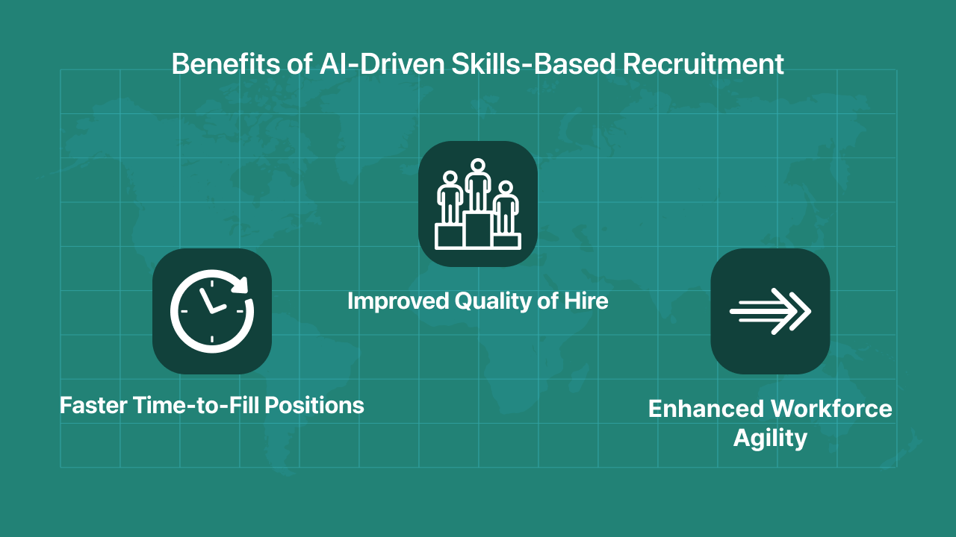

18. Resume Scoring Algorithm

The Resume Scoring Algorithm is designed to evaluate and rank resumes based on their relevance to job requirements. It provides a numerical score that represents the overall quality and suitability of a resume for a specific job role.
The scoring process is based on multiple parameters such as skill matching, experience relevance, educational qualifications, keyword density, and ATS compatibility. Each parameter is assigned a specific weight depending on its importance in the recruitment process.
For example, skill matching carries higher weightage because it directly reflects job suitability, while formatting and keyword usage contribute moderately to the final score.
Machine learning techniques such as cosine similarity are used to compare resumes with job descriptions. This helps in identifying how closely a candidate profile matches the job requirements.
The system also ensures that resumes are not just keyword-filled but contextually meaningful. For instance, simply repeating keywords without proper experience does not result in a high score.
The final resume score helps candidates understand their strengths and weaknesses. It also assists recruiters in shortlisting candidates more efficiently by filtering out low-relevance profiles.

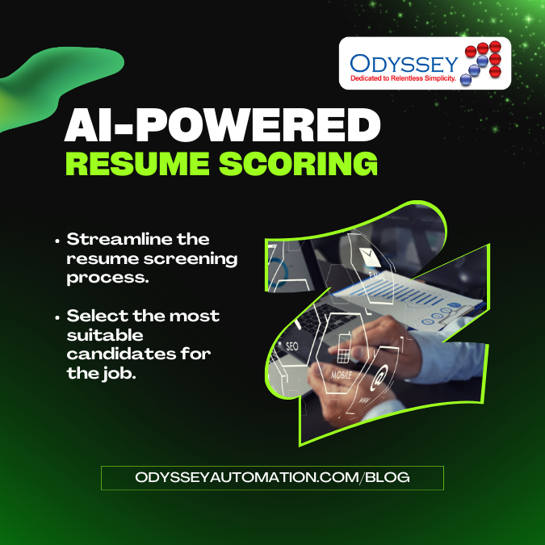

19. ATS Compatibility Analysis

The ATS Compatibility Analysis module is a crucial component of the RecruitX AI system that helps candidates evaluate whether their resumes are optimized for Applicant Tracking Systems (ATS). ATS software is widely used by organizations and recruitment agencies to automatically screen, filter, and rank resumes before they are reviewed by human recruiters. Since a large percentage of resumes are rejected during this initial screening process, ATS optimization plays a significant role in improving a candidate’s chances of securing interview opportunities.
The primary objective of this module is to assess the ATS-friendliness of a resume and provide recommendations for improvement. It analyzes the resume’s structure, formatting, content organization, and keyword relevance to determine how effectively it can be processed by automated recruitment systems. By identifying potential issues, the module helps candidates create resumes that are both recruiter-friendly and machine-readable.
The ATS Compatibility Analysis process begins after the Resume Parsing Module extracts information from the uploaded document. The system examines the overall layout and structure of the resume to ensure that essential sections are clearly defined and properly organized. Standard sections such as Career Objective, Professional Summary, Technical Skills, Educational Qualifications, Work Experience, Projects, Certifications, Achievements, and Contact Information are checked for completeness and clarity.
The module evaluates whether the resume follows ATS-friendly formatting practices. Many Applicant Tracking Systems have difficulty processing resumes that contain excessive graphics, images, icons, text boxes, complex tables, multiple columns, headers, footers, or decorative design elements. Such formatting choices can prevent important information from being correctly extracted and interpreted by automated systems. Therefore, the module identifies formatting issues that may negatively affect ATS performance.
Font selection and document readability are also analyzed during the evaluation process. ATS software typically performs best with standard fonts such as Arial, Calibri, Times New Roman, or Helvetica. Unusual fonts, excessive styling, or inconsistent formatting can reduce machine readability. The system checks these aspects and provides recommendations to ensure optimal compatibility.
One of the most important functions of the ATS Compatibility Analysis module is keyword optimization. Modern ATS platforms use keyword-based matching techniques to compare resumes with job descriptions.

20. Job Role Prediction using Machine Learning

The Job Role Prediction module uses machine learning algorithms to identify suitable job roles for a candidate based on their resume data. It helps users discover career paths that match their skills and experience.
The model is trained using historical datasets that contain resumes mapped to job roles. Classification algorithms such as Random Forest, Decision Tree, and Naive Bayes are commonly used for prediction.
Input features include extracted skills, education level, work experience, certifications, and project details. These features are converted into numerical representations before feeding them into the model.
The system analyzes patterns in the dataset and learns how specific combinations of skills correspond to different job roles such as Data Analyst, Software Developer, or Machine Learning Engineer.
The model improves over time as more data is added, making predictions more accurate and reliable.
This module is beneficial for students and job seekers as it helps them understand which career path best suits their profile.

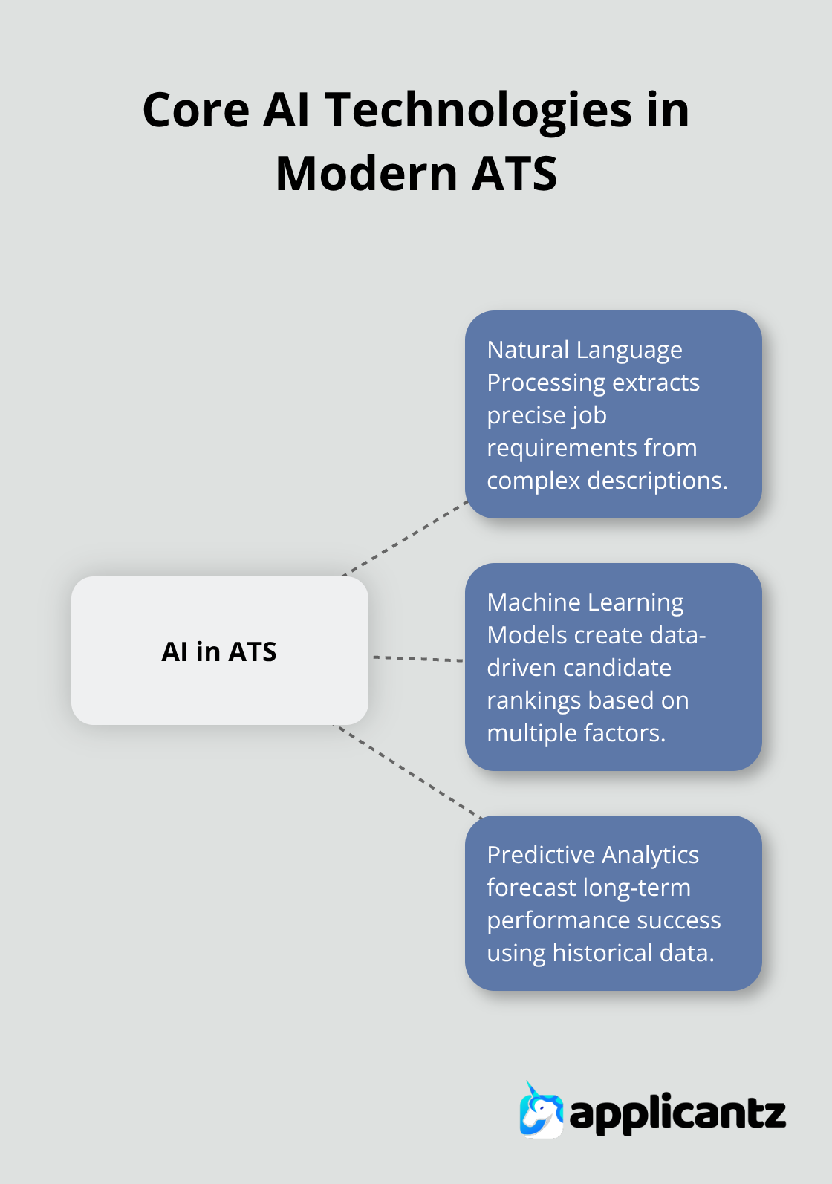

21. Company Recommendation Engine

The Company Recommendation Engine is one of the most important modules in the RecruitX AI system. Its primary objective is to recommend suitable companies to candidates based on their skills, qualifications, experience, career goals, and predicted job roles. Instead of requiring users to manually search through thousands of job listings, the recommendation engine intelligently identifies organizations that best match the candidate’s profile and interests.
The system uses Artificial Intelligence and Machine Learning techniques to analyze candidate data and generate personalized recommendations. It collects information from resumes, skill assessments, educational qualifications, certifications, and previous job experiences. This information is then compared with company requirements and hiring patterns to identify the most relevant opportunities.
The recommendation engine utilizes content-based filtering and collaborative filtering techniques. Content-based filtering works by comparing candidate skills and attributes with company requirements and job descriptions. If a candidate possesses skills that closely match the requirements of a particular company, that company receives a higher recommendation score. Collaborative filtering, on the other hand, identifies similarities among users and recommends companies that have been preferred or selected by candidates with similar profiles and career interests.
The engine also considers multiple factors such as industry domain, company size, geographical location, salary expectations, work environment, and employment type. Candidates may specify their preferences for remote work, hybrid work, or on-site employment. These preferences are incorporated into the recommendation process to ensure that the suggested companies align with the candidate’s personal and professional goals.
For example, if a candidate possesses skills in Python, Machine Learning, Data Science, and Artificial Intelligence, the system may recommend companies involved in AI research, data analytics, software development, and product-based technology solutions. Similarly, candidates with expertise in web development and cloud computing may receive recommendations for software service companies, startups, and cloud-based technology organizations.
The recommendation engine continuously updates its suggestions as users modify their profiles or acquire new skills. Whenever a candidate uploads a new certification, updates their resume, or gains additional experience, the recommendation model recalculates
potential employers, making the recruitment process faster, smarter, and more efficient.

22. Skill Gap Analysis

The Skill Gap Analysis module is a powerful feature of the RecruitX AI system that helps candidates understand the difference between their current skill set and the skills required for a specific job role. It serves as a personalized career development tool by identifying areas where improvement is needed and providing guidance for skill enhancement. This module enables users to make informed decisions about their learning path and career growth.
The primary objective of Skill Gap Analysis is to evaluate a candidate’s qualifications and compare them with industry expectations. The system extracts skills from the candidate’s resume using Natural Language Processing (NLP) techniques and compares them with the skills listed in job descriptions, industry standards, and employer requirements. This comparison helps identify missing, weak, or partially matched skills that may affect the candidate’s suitability for a particular role.
For example, if a candidate is interested in becoming a Machine Learning Engineer, the job requirements may include Python, Machine Learning, Deep Learning, SQL, Data Visualization, and Cloud Computing. If the candidate possesses only Python and basic Machine Learning knowledge, the system identifies Deep Learning, SQL, Data Visualization, and Cloud Computing as skill gaps. These gaps are then presented to the user in an easy-to-understand format.
The module uses advanced matching algorithms and similarity calculations to measure the alignment between candidate skills and required skills. Each skill is assigned a relevance score, indicating the level of proficiency or match. Based on these scores, the system categorizes skills into matched skills, partially matched skills, and missing skills. This structured analysis provides users with a clear understanding of their strengths and weaknesses.
To improve user experience, the results are displayed using charts, graphs, progress bars, and visual indicators. These visual representations make it easier for candidates to interpret the analysis and quickly identify the areas that need attention. For instance, a skill match percentage can be shown through progress bars, while missing skills may be highlighted using warning indicators or separate sections.
The Skill Gap Analysis module also prioritizes skills based on market demand and industry relevance. Certain skills may have a greater impact on employability than others. Therefore, the system ranks missing skills according to their importance in the target job role. High-demand skills such as Artificial Intelligence, Data Science, Cloud Computing,

23. Learning Roadmap Generator

The Learning Roadmap Generator is an intelligent module of the RecruitX AI system designed to help candidates develop the skills required for their desired career paths. Based on the results obtained from the Skill Gap Analysis module, it creates a personalized and structured learning plan that guides users from their current skill level to their target job role. This module acts as a virtual career mentor by providing clear and organized learning directions.
The primary objective of the Learning Roadmap Generator is to eliminate uncertainty in the learning process. Many candidates struggle to identify which skills to learn first and how to progress effectively toward their career goals. This module addresses that challenge by creating a step-by-step roadmap that focuses on the most important skills required for a specific profession or industry.
The system begins by analyzing the candidate’s existing skills, educational background, certifications, and career aspirations. It then compares this information with industry requirements and identifies the skills that need improvement. Based on these findings, the module generates a customized learning path that gradually builds the required competencies.
For example, if a candidate aims to become a Machine Learning Engineer but lacks sufficient technical knowledge, the roadmap may start with Python programming fundamentals, followed by statistics, data analysis, machine learning algorithms, deep learning concepts, and real-world AI projects. Each stage builds upon the previous one, ensuring a smooth and effective learning experience.
The Learning Roadmap Generator categorizes learning materials into beginner, intermediate, and advanced levels. This structured approach ensures that users gain a strong foundation before moving to more complex topics. By following a progressive learning sequence, candidates can develop a deeper understanding of concepts and improve long-term retention of knowledge.
To support effective learning, the roadmap includes recommendations for various educational resources such as online courses, video tutorials, certification programs, technical blogs, e-books, research papers, coding practice platforms, and project-based learning activities. These resources are carefully selected to align with the candidate’s learning objectives and career goals.

24. Interview Question Generator

The Interview Question Generator is an advanced module of the RecruitX AI system designed to help candidates prepare effectively for job interviews. This module automatically generates customized interview questions based on a candidate’s resume, skills, experience, educational background, and target job role. By providing personalized interview preparation, it enables users to build confidence and improve their chances of success during recruitment processes.
The primary objective of this module is to simulate real interview experiences by generating questions that closely match industry expectations. Traditional interview preparation methods often involve practicing generic questions that may not be relevant to a specific role. The Interview Question Generator overcomes this limitation by creating role-specific and skill-based questions tailored to each candidate’s profile.
The system begins by analyzing the candidate’s resume using Natural Language Processing (NLP) techniques. It extracts important information such as technical skills, certifications, projects, work experience, educational qualifications, and career interests. Simultaneously, it examines job descriptions to identify the competencies and knowledge areas required for the target position. Based on this analysis, the module generates a set of interview questions that align with the candidate’s intended career path.
The generated questions are categorized into multiple sections, including technical questions, behavioral questions, aptitude questions, situational questions, and problem-solving challenges. This comprehensive approach ensures that candidates are prepared for all aspects of the interview process rather than focusing solely on technical knowledge.
For example, if a candidate applies for a Software Engineering role, the system may generate questions related to programming languages, data structures, algorithms, object-oriented programming, database management systems, operating systems, and software development methodologies. Candidates targeting Artificial Intelligence or Machine Learning roles may receive questions on Python, Machine Learning algorithms, Deep Learning concepts, Neural Networks, Data Science, and Artificial Intelligence applications.
Behavioral interview questions are also generated to assess communication skills, teamwork, leadership qualities, adaptability, and professional ethics. Examples include questions about handling workplace challenges, resolving conflicts, managing deadlines, and collaborating with team members. These questions help candidates prepare for Human Resource (HR) interviews and organizational culture assessments.

25. Salary Prediction Module

The Salary Prediction Module is an intelligent component of the RecruitX AI system that helps candidates estimate their potential salary based on their qualifications, skills, experience, and target job roles. This module provides valuable insights into current market compensation trends, enabling users to make informed career decisions and set realistic salary expectations during job applications and interviews.
The primary objective of the Salary Prediction Module is to analyze various candidate attributes and predict an appropriate salary range that aligns with industry standards. Instead of relying on assumptions or outdated information, candidates can use data-driven predictions to better understand their market value and identify opportunities for career growth.
The module collects and analyzes multiple factors that influence salary determination. These factors include educational qualifications, technical skills, certifications, years of experience, job role, industry domain, geographical location, company size, and market demand for specific skills. By considering these variables, the system generates more accurate and meaningful salary estimates.
Machine Learning regression algorithms play a significant role in this module. Historical salary datasets are used to train predictive models capable of identifying relationships between candidate profiles and compensation levels. Algorithms such as Linear Regression, Random Forest Regression, Decision Tree Regression, and Gradient Boosting Regression can be applied to learn salary patterns from existing data. Once trained, these models predict salary ranges for new candidates based on their profile information.
For example, a candidate with a Bachelor's degree, strong Python programming skills, Machine Learning expertise, and two years of professional experience may receive a different salary prediction compared to a candidate with similar education but limited technical skills. Similarly, professionals possessing specialized skills such as Artificial Intelligence, Cloud Computing, Cybersecurity, Data Science, or DevOps may receive higher salary estimates due to increased industry demand.
The Salary Prediction Module also considers location-based salary variations. Compensation levels often differ significantly across cities, states, and countries due to differences in living costs, economic conditions, and market demand. For instance, technology professionals working in major metropolitan areas may earn higher salaries compared to those working in smaller cities. By incorporating geographical information, the module provides more realistic and region-specific predictions.

26. AI Career Assistant Chatbot

The AI Career Assistant Chatbot is an intelligent conversational module integrated into the RecruitX AI system to provide continuous career guidance and support to users. It acts as a virtual career mentor that assists candidates in various stages of their professional journey, including resume building, job searching, interview preparation, skill development, and career planning. By offering instant responses and personalized recommendations, the chatbot enhances user engagement and simplifies the overall recruitment experience.
The primary objective of the AI Career Assistant Chatbot is to provide real-time assistance and answer user queries efficiently. Many candidates often face challenges while preparing resumes, selecting career paths, identifying required skills, or preparing for interviews. The chatbot addresses these challenges by providing accurate information and guidance whenever needed, eliminating the dependency on manual support systems.
The chatbot uses Natural Language Processing (NLP) techniques to understand user queries expressed in natural language. NLP enables the system to interpret the intent behind user questions, extract important keywords, and generate meaningful responses. As a result, users can communicate with the chatbot in a conversational manner rather than using predefined commands or structured inputs.
For example, a user may ask questions such as “How can I improve my resume?”, “What skills are required for a Data Scientist role?”, “How should I prepare for a software engineering interview?”, or “Which certifications will help me get a Machine Learning job?”. The chatbot analyzes these queries and provides detailed, context-aware responses tailored to the user's profile and career objectives.
One of the key features of the chatbot is personalized career guidance. By accessing information from the candidate’s profile, resume analysis, skill gap assessment, and job role predictions, the chatbot delivers customized recommendations. It can suggest relevant skills to learn, recommend suitable job roles, provide company recommendations, and offer strategies for improving employability.
The AI Career Assistant Chatbot also assists users in resume optimization. It reviews resume content, identifies areas for improvement, and suggests modifications that can enhance the resume’s effectiveness. Recommendations may include adding missing technical skills, improving project descriptions, highlighting achievements, and optimizing keyword usage to increase compatibility with Applicant Tracking Systems (ATS).

27. User Interface Design

The User Interface (UI) Design of RecruitX AI is developed with a strong focus on simplicity, usability, accessibility, and user satisfaction. The primary objective of the interface is to provide a smooth and intuitive experience that allows users to interact with the system efficiently without requiring extensive technical knowledge. A well-designed user interface plays a crucial role in ensuring that users can easily access the platform’s features, understand analytical results, and make informed career decisions.
The design philosophy of RecruitX AI emphasizes user-centered design principles. Every component of the interface is created to minimize complexity and maximize ease of use. The platform provides a structured and organized layout that enables users to navigate between different modules such as Resume Analysis, Job Role Prediction, Skill Gap Analysis, Learning Roadmap Generation, Company Recommendations, Salary Prediction, Interview Preparation, and AI Career Assistant Chatbot without confusion.
One of the key elements of the interface is the Resume Upload Section. This section allows candidates to upload their resumes in various formats such as PDF and DOCX files. The upload process is designed to be simple and user-friendly, with drag-and-drop functionality and clear instructions to guide users through the process. Once uploaded, the system automatically processes the resume and displays analysis results.
The platform also includes interactive dashboards that provide a comprehensive overview of candidate information and analytical outcomes. These dashboards present important metrics such as resume scores, skill match percentages, job role predictions, recommendation scores, and profile completion status. By displaying critical information in a centralized location, users can quickly understand their current standing and identify areas that require improvement.
Data visualization plays a significant role in enhancing the user experience. The interface incorporates graphs, charts, progress bars, and visual indicators to represent complex analytical results in an easy-to-understand format. For example, resume performance scores can be displayed using bar charts, skill gaps can be highlighted through progress indicators, and salary predictions can be visualized using trend graphs. These visual elements make data interpretation faster and more effective.

28. Testing and Validation

The Testing and Validation phase ensures that the RecruitX AI system performs accurately, efficiently, and reliably under different working conditions. This phase is one of the most critical parts of system development because it helps identify errors, improve system quality, and ensure that the final output meets the expected requirements.
Unit testing is conducted to verify individual modules of the system independently. Each component such as NLP-based text processing, resume parsing module, feature extraction logic, and machine learning prediction models is tested separately. This helps in detecting bugs at an early stage and ensures that every module is functioning correctly before integration. For example, the resume parser is tested with different formats like PDF, DOCX, and TXT to ensure proper extraction of skills, education, and experience.
Integration testing is performed to check whether all modules of the system work together without conflicts. After unit testing, components like the frontend interface, backend processing, NLP pipeline, and ML prediction engine are combined and tested as a single workflow. This ensures smooth data flow between modules, such as passing parsed resume data into the prediction model without errors or data loss.
System testing evaluates the complete RecruitX AI application as a whole system. It verifies whether the system meets the functional and non-functional requirements specified during the design phase. This includes checking user interactions, resume upload functionality, prediction accuracy, and output generation. System testing ensures that the application behaves correctly in real-world usage scenarios.
The system is also tested using real-world resume datasets collected from different domains such as software engineering, data science, and marketing. These datasets help in validating the accuracy and robustness of the AI model. By comparing predicted outcomes with actual expected results, the system’s reliability and performance are measured effectively.
Performance testing is carried out to evaluate system efficiency under heavy data loads and multiple user requests. It checks key factors such as response time, processing speed, memory usage, and scalability. This ensures that the system can handle large volumes of resumes simultaneously without lag or failure. Load testing and stress testing are also performed to understand system behavior under extreme conditions.

outputs:
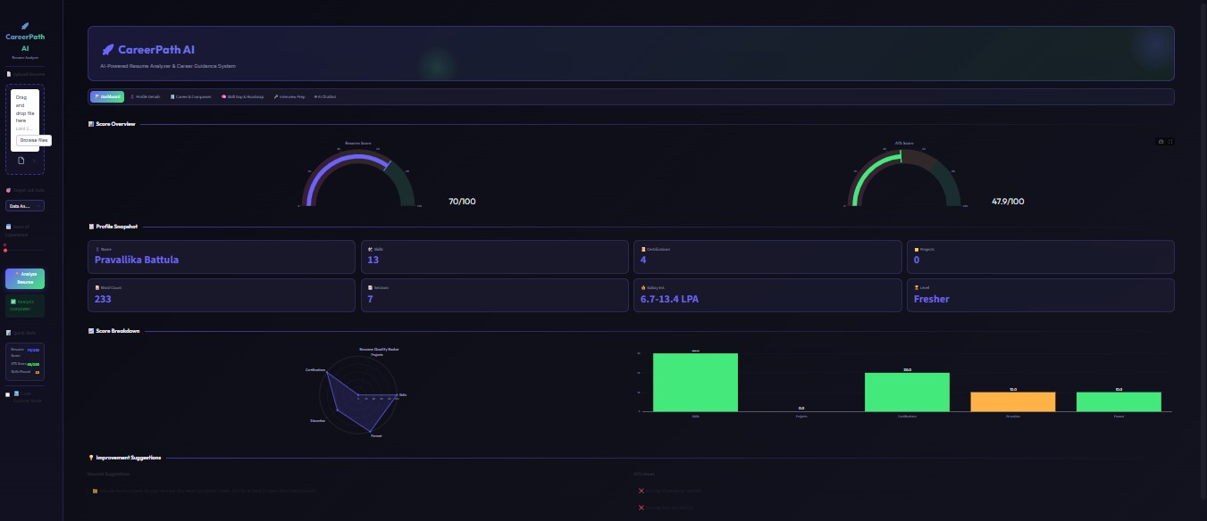

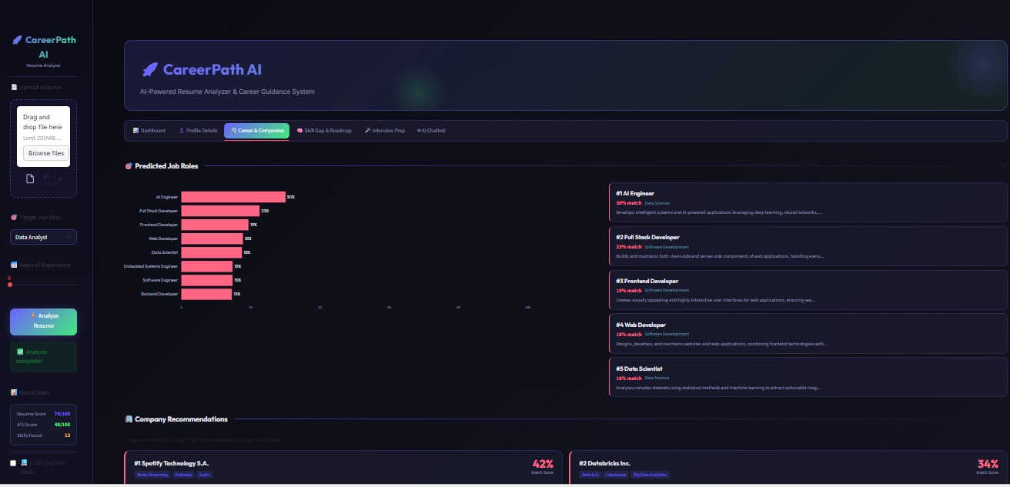



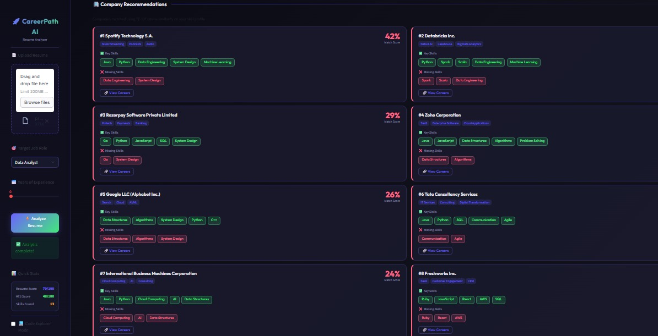

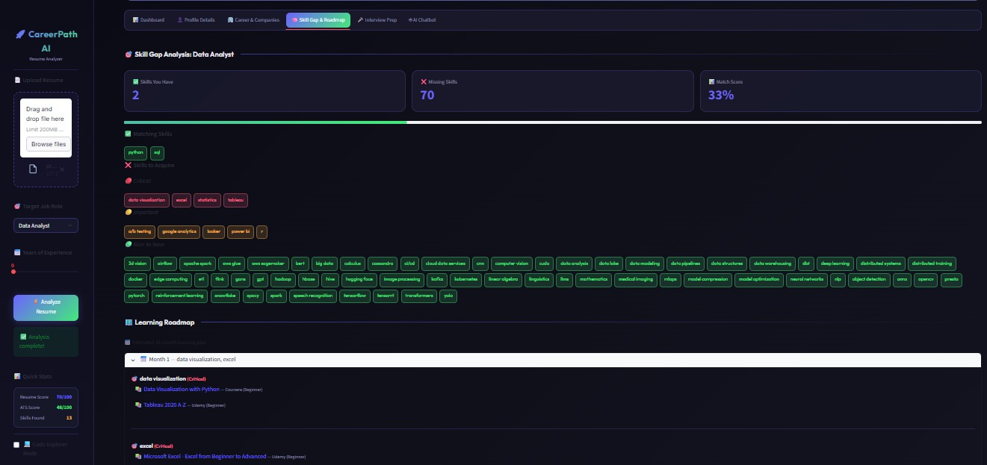


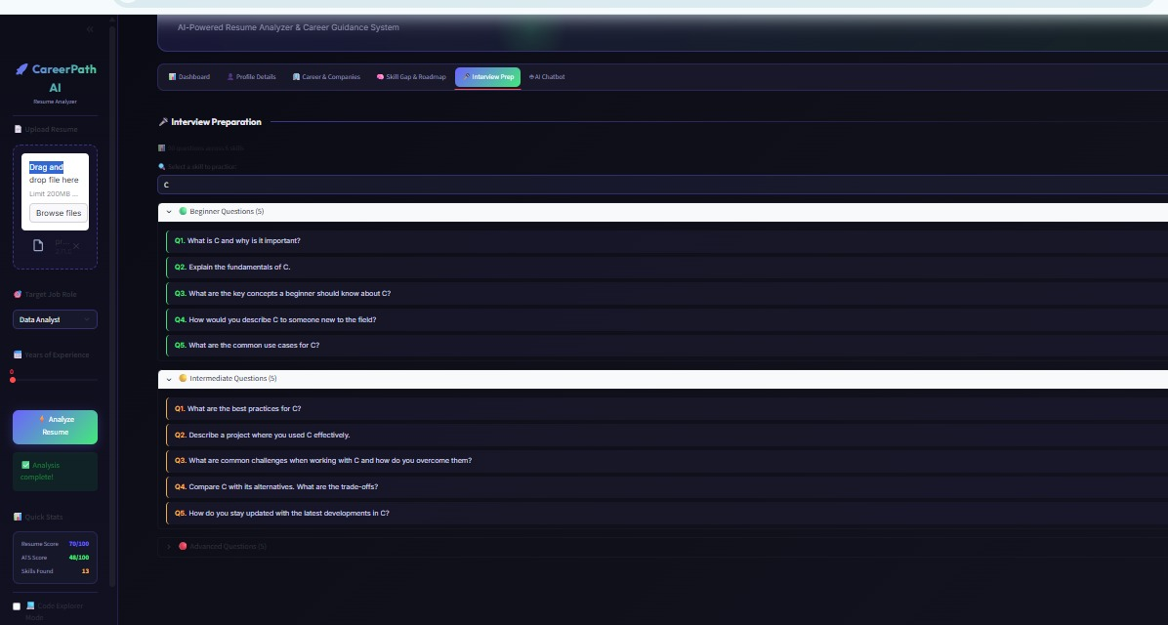
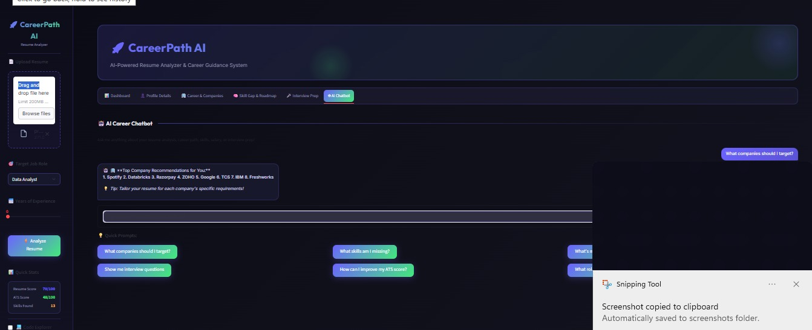

29. Future Enhancements

The RecruitX AI system has several promising opportunities for future improvement that can significantly enhance its performance, usability, and real-world applicability. As technology continues to evolve, the system can be upgraded to incorporate more advanced features and intelligent capabilities, making it more industry-ready and user-friendly.
One of the major enhancements is the integration of deep learning models, such as neural networks and transformer-based architectures. These models can improve the accuracy of resume analysis, skill matching, and candidate-job prediction. By learning complex patterns from large datasets, deep learning can provide more personalized and precise recruitment recommendations compared to traditional machine learning approaches.
Another important improvement is the addition of real-time job scraping and job recommendation systems. By integrating APIs or web scraping techniques from platforms like LinkedIn and Indeed, the system can fetch live job postings automatically. This will allow candidates to receive up-to-date job opportunities based on their skills and preferences, making the platform more dynamic and useful.
The development of a mobile application version is also a key enhancement. A mobile app will increase accessibility and allow users to upload resumes, view job matches, and receive notifications on the go. This will improve user engagement and make the system more convenient for students, job seekers, and professionals.
Additionally, multilingual support can be introduced to make the system accessible to users from different linguistic backgrounds. By supporting multiple languages, RecruitX AI can expand its reach globally and assist users who are not comfortable with English. This can be achieved using natural language processing techniques and translation APIs.
Future versions of the system can also include AI-powered chatbots to guide users through resume building, interview preparation, and job application processes. These intelligent assistants can provide real-time suggestions and improve user experience.
Furthermore, advanced analytics dashboards can be developed for recruiters to visualize candidate insights, skill distributions, and hiring trends. This will help organizations make more informed hiring decisions using data-driven insights.
Implementing cloud deployment and scalability improvements using platforms like AWS, Azure, or Google Cloud can also enhance system performance. This will ensure that the system can handle a large number of users and resume data efficiently without performance issues.

30. Conclusion

The RecruitX AI project is an intelligent and innovative system designed to enhance and simplify the recruitment and job search process by leveraging the power of Artificial Intelligence (AI) and Machine Learning (ML) technologies. In today’s competitive job market, it becomes difficult for candidates to identify the right opportunities and for recruiters to filter the most suitable applicants efficiently. This system addresses these challenges by automating and optimizing the entire recruitment workflow.
The platform assists candidates by analyzing their resumes in detail and extracting important information such as skills, education, experience, and domain expertise. Based on this analysis, the system identifies skill gaps and provides personalized career recommendations, helping users understand what improvements are needed to achieve their desired job roles. This makes career planning more structured and goal-oriented.
One of the key features of RecruitX AI is the automation of resume evaluation. Traditional hiring processes are time-consuming and often biased, but this system ensures faster and more consistent evaluation using AI-based algorithms. It also provides accurate job role predictions by comparing candidate profiles with industry requirements, making the job search process more efficient, transparent, and data-driven.
By integrating technologies such as Natural Language Processing (NLP), machine learning models, and advanced data analysis techniques, RecruitX AI effectively bridges the gap between job seekers and recruiters. It ensures that the right candidate is matched with the right job role based on skills and compatibility rather than manual filtering alone.
Furthermore, this project demonstrates how AI can be practically applied to solve real-world career-related challenges. It improves decision-making, reduces manual effort, and enhances the overall hiring experience for both candidates and organizations.
Overall, RecruitX AI represents a step forward in modernizing the recruitment process, making it smarter, faster, and more efficient. With further enhancements, it has the potential to become a powerful industry-level solution in the field of intelligent hiring systems.

31. References

The development of RecuitX AI is supported by various technical resources, research papers, and online platforms.
Official documentation of Python and its libraries such as Scikit-learn, Pandas, NumPy, and NLTK were used extensively.
Machine learning concepts were studied from academic textbooks and online learning platforms.
Research papers on Natural Language Processing, resume parsing, and recommendation systems were referred to for improving system design.
Platforms like GitHub, Kaggle, and Stack Overflow were used for datasets, code references, and implementation support.

